Maurice Farr Module 06 Programming Assignment, Part 1 Due Date: 12/1/2024

**Assignment Description:** Module 06 Programming Assignment, Part 1

**Readme Documentation:**

• Assignment Part I: Write a GUI program that converts Celsius temperatures to Fahrenheit temperatures. The user should be able to enter a Celsius temperature, click a button, then see the equivalent Fahrenheit temperature. Use the following formula to make the conversion:

F = 9/5 * C + 32

F is the Fahrenheit temperature, and C is the Celsius temperature.

You should allow the user to enter a generic temperature and have two buttons -- one to treat the input as Fahrenheit and convert it to Celsius; and one to treat the input as Celsius and convert it to Fahrenheit.

**Source Code of All files (.py):**

# header information

"""

author: Maurice Farr

date: 11/30/2024

assignment: Module 06 Programming Assignment, Part 1

purpose: We need to create a GUI application that changes Celsius temperatures into Fahrenheit.

The user will input a Celsius temperature, press a button, and then view the corresponding Fahrenheit temperature.

The conversion formula to use is F = 9/5 * C + 32, where F represents Fahrenheit and C represents Celsius.

Additionally, the program should let users input any temperature and provide two buttons: one for converting from Fahrenheit to Celsius and another for converting from Celsius to Fahrenheit.

"""

#FarrMauriceM#6M#3Ex1.py

from tkinter import *

from tkinter import messagebox

#Define the function to convert Celsius temperature to Fahrenheit temperature

def celsiusTemperature_to_fahrenheitTemperature():

try:

celsius = float(text_entry.get()) #Get the input temperature in Celsius

fahrenheit = (9/5) * celsius + 32 #Convert Celsius temperature to Fahrenheit temperature

results_label.config(text=f"{celsius}°C = {fahrenheit:.2f}°F")

except ValueError:

messagebox.showerror("Invalid Input", "Please enter a valid number.") #Indication of invalid input

#Define the function to convert Fahrenheit temperature to Celsius temperature

def fahrenheitTemperature_to_CelsiusTemperature():

try:

fahrenheit = float(text_entry.get()) #Get the input temperature in Fahrenheit

celsius = (fahrenheit - 32) * 5/9 #Convert Fahrenheit temperature to Celsius temperature

results_label.config(text=f"{fahrenheit}°F = {celsius:.2f}°C")

except ValueError:

messagebox.showerror("Invalid Input", "Please enter a valid number.") #Indication of invalid input

#Create the main window including adding the title

index = Tk()

index.title("Convert the Temperature")

#Create and add the grid layout for the label input

entry_input_label = Label(index, text="Enter the temperature:")

entry_input_label.grid(row=0, column=0, padx=12, pady=12)

#Create and add the grid layout for the text entry for the user input

text_entry = Entry(index)

text_entry.grid(row=0, column=1, padx=12, pady=12)

#Create and add the grid layouts for the Celsius to Fahrenheit button

celsius_to_fahrenheit_button = Button(index, text="Convert to Fahrenheit", command=celsiusTemperature_to_fahrenheitTemperature)

celsius_to_fahrenheit_button.grid(row=1, column=0, padx=12, pady=12)

#Create and add the grid layouts for the Fahrenheit to Celsius button

fahrenheit_to_celsius_button = Button(index, text="Convert to Celsius", command=fahrenheitTemperature_to_CelsiusTemperature)

fahrenheit_to_celsius_button.grid(row=1, column=1, padx=12, pady=12)

#Create and add the grid layouts for the results label

results_label = Label(index, text="Display the results.")

results_label.grid(row=2, column=0, columnspan=2, padx=12, pady=12)

#Run the main loop

index.mainloop()

**Testing Screenshot #1:**

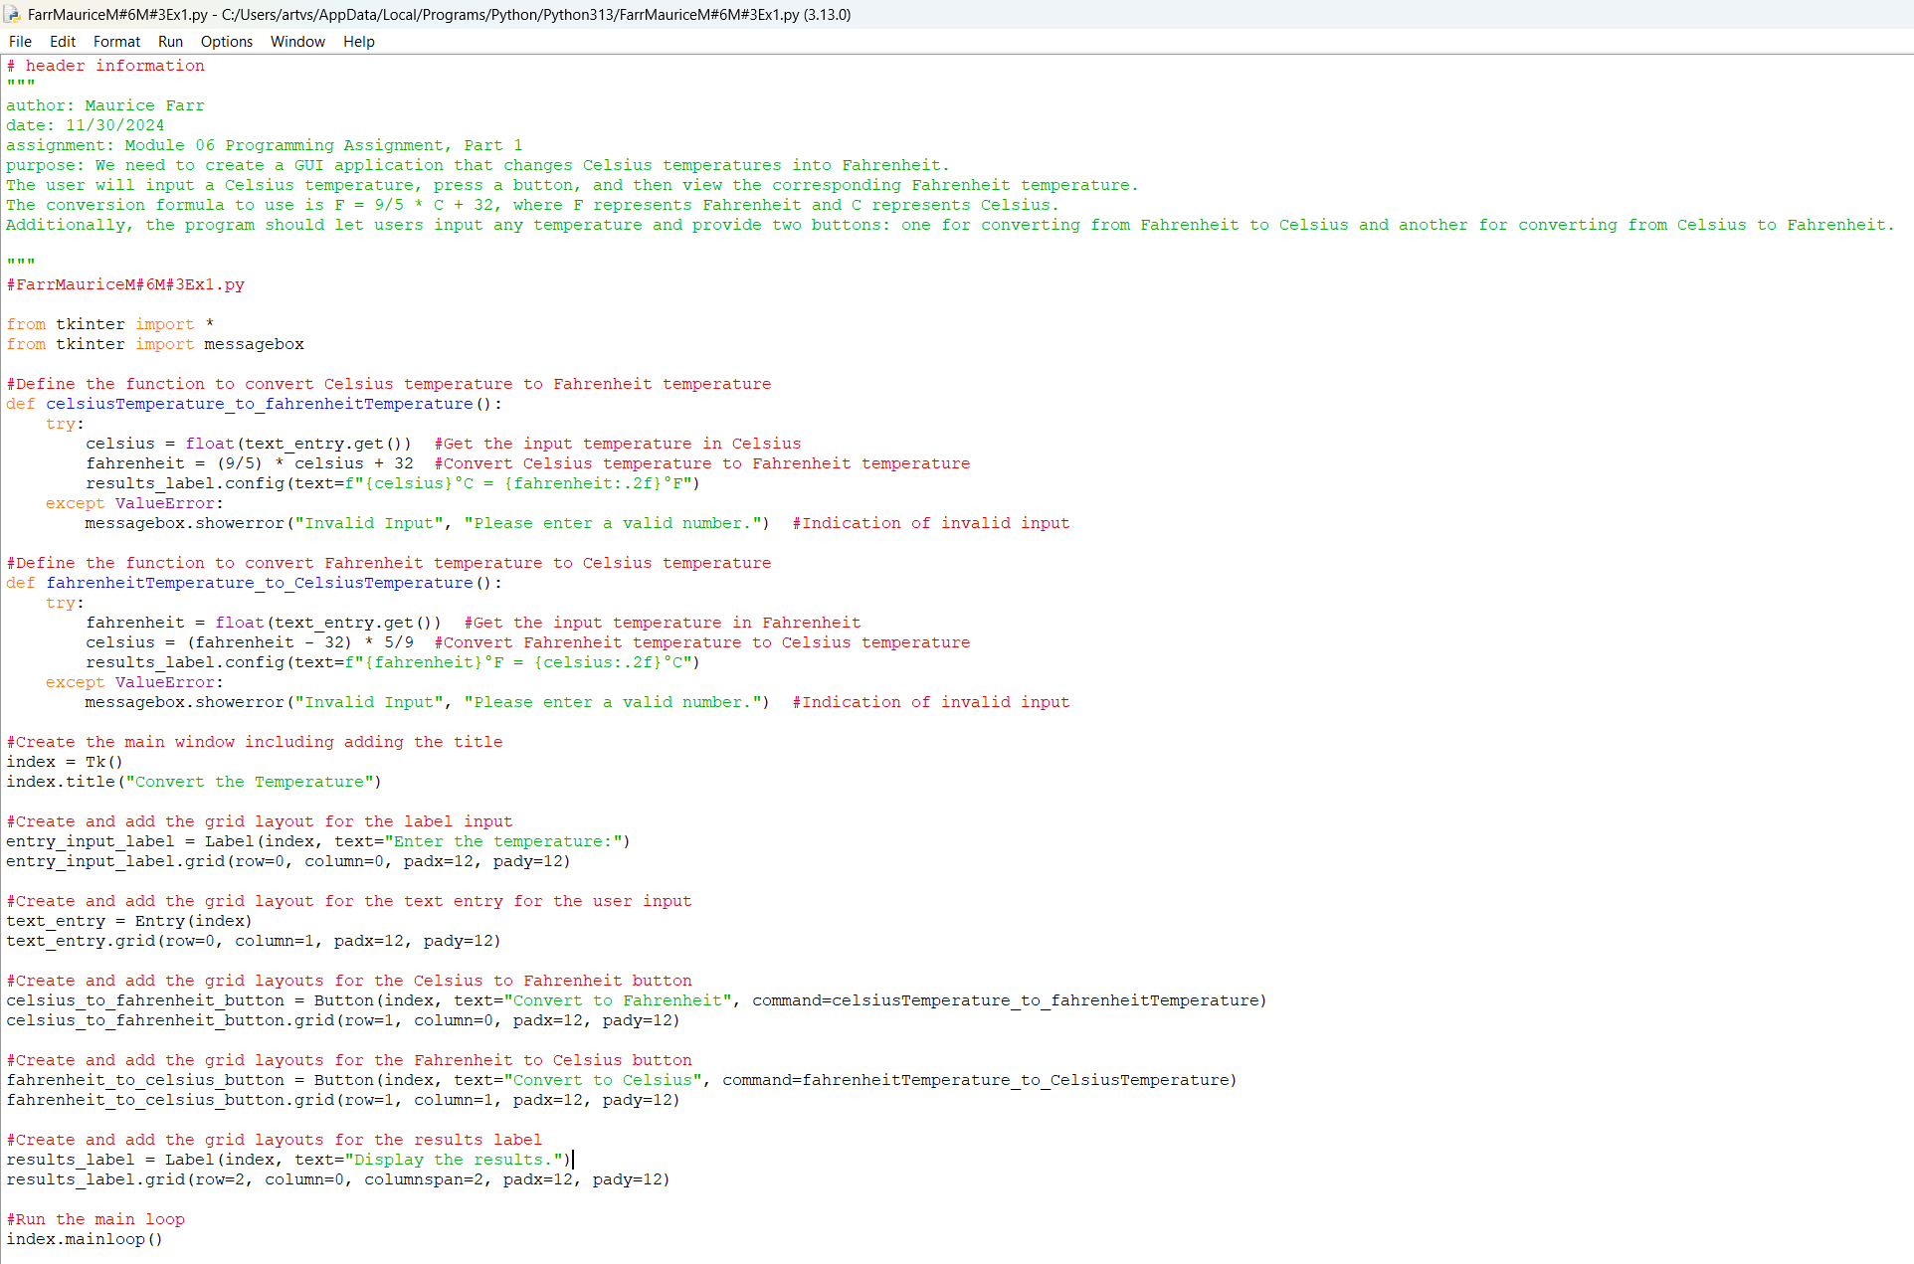

**Testing Screenshot #2:**

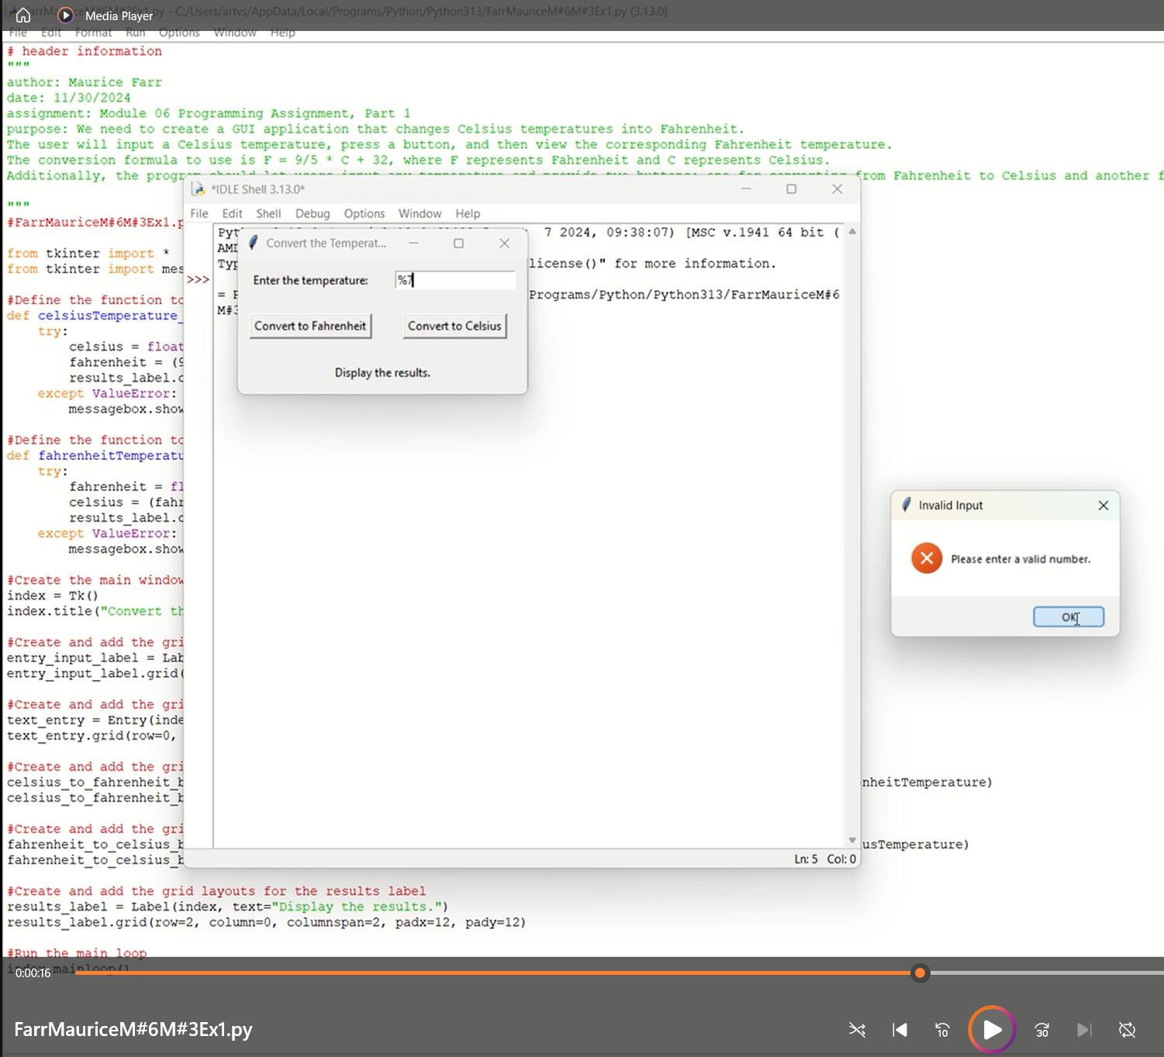

**Testing Screenshot #3:**

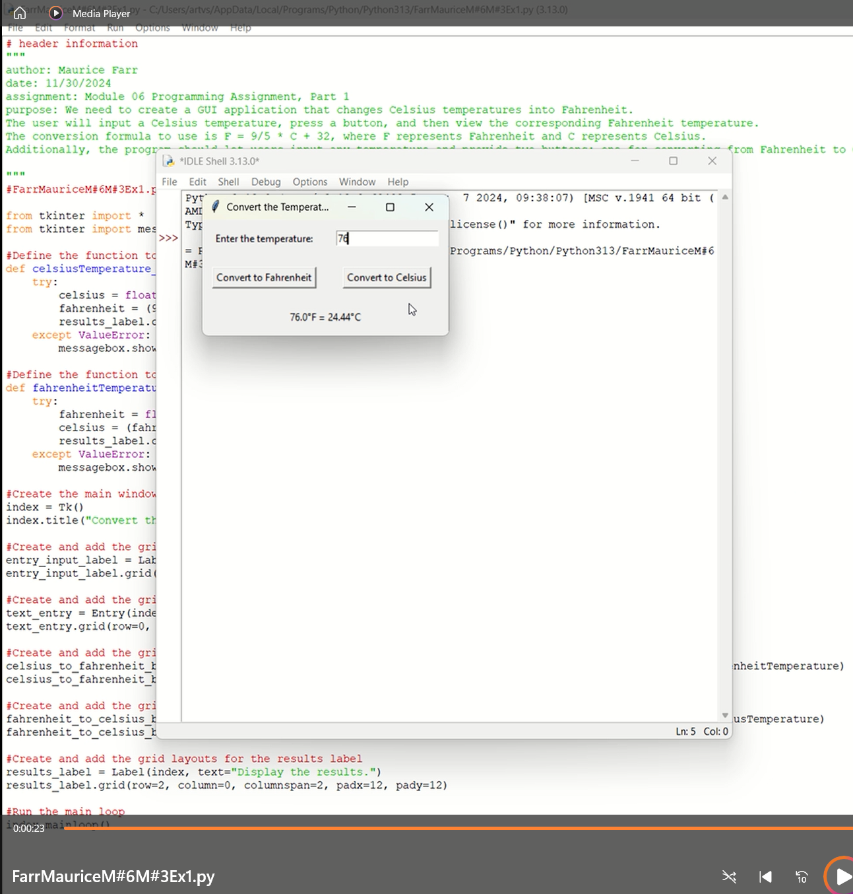

**Testing Screenshot #4:**

